

Practices for Secure Software Report

Table of Contents
Document Revision History 3
Client 3
Instructions 3
Developer 4
1. Algorithm Cipher 4
2. Certificate Generation 4
3. Deploy Cipher 4
4. Secure Communications 4
5. Secondary Testing 4
6. Functional Testing 4
7. Summary 4
8. Industry Standard Best Practices 4

Document Revision History

Version | Date | Author | Comments
1.0 | [Date] | [Your Name]

Client



Instructions

Submit this completed practices for secure software report. Replace the bracketed text with the relevant information. You must document your process for writing secure communications and refactoring code that complies with software security testing protocols.

- Respond to the steps outlined below and include your findings.
- Respond using your own words. You may also choose to include images or supporting materials. If you include them, make certain to insert them in all the relevant locations in the document.
- Refer to the Project Two Guidelines and Rubric for more detailed instructions about each section of the template.

Developer
Malaki Guenther

Algorithm Cipher
For Artemis Financial’s web application I recommend deploying AES-256-GCM (Advanced Encryption Standard 256-bit key in Galois/Counter Mode) as the primary symmetric encryption algorithm within TLS.
AES-256-GCM is an authenticated encryption (AEAD) cipher that provides both confidentiality and integrity in a single operation. It uses a 256-bit key, 128-bit block size, a 12-byte nonce (IV), and built-in GHASH authentication. It is symmetric (same key encrypts/decrypts) and is the only cipher suite class still allowed in TLS 1.3. As of 2025, AES-256-GCM remains unbroken, is required for U.S. Government Top Secret data, and is universally recommended by NIST, OWASP, ENISA, and all major industry standards. This makes it the most secure and future-proof choice for protecting Artemis Financial’s sensitive data in transit and at rest.

Certificate Generation
Insert a screenshot below of the CER file.

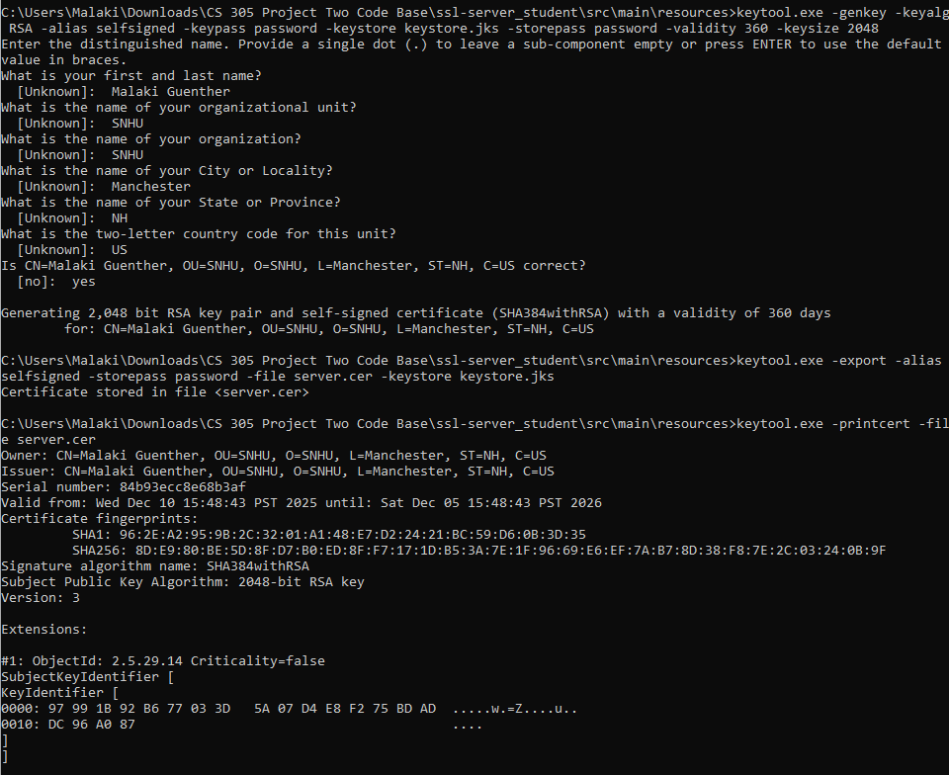

Deploy Cipher
Insert a screenshot below of the checksum verification.
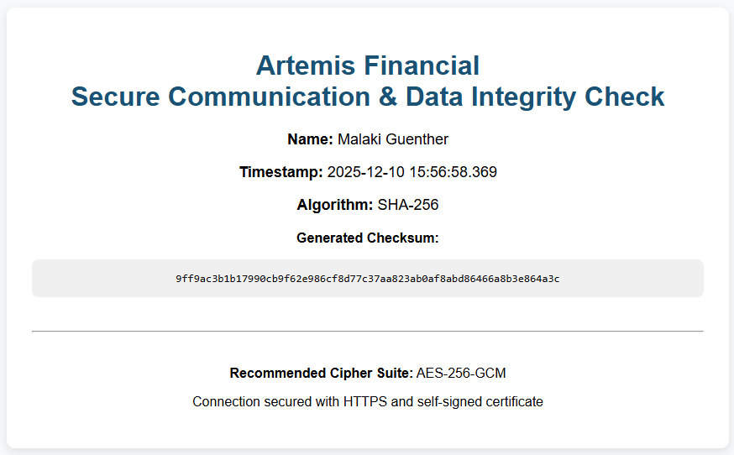

Secure Communications
Insert a screenshot below of the web browser that shows a secure webpage.

Self-signed and it realizes and warns you that it's self-signed. That's why it's crossed out.

Secondary Testing
Insert screenshots below of the refactored code executed without errors and the dependency-check report.
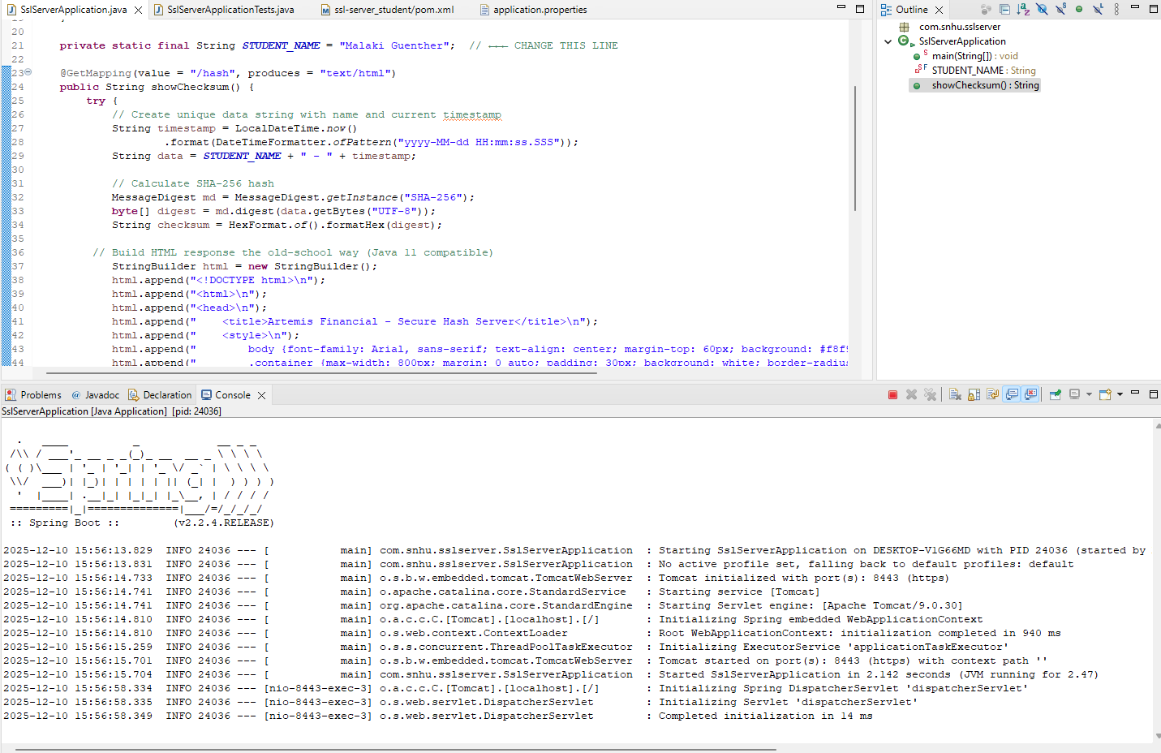

Functional Testing
Insert a screenshot below of the refactored code executed without errors.
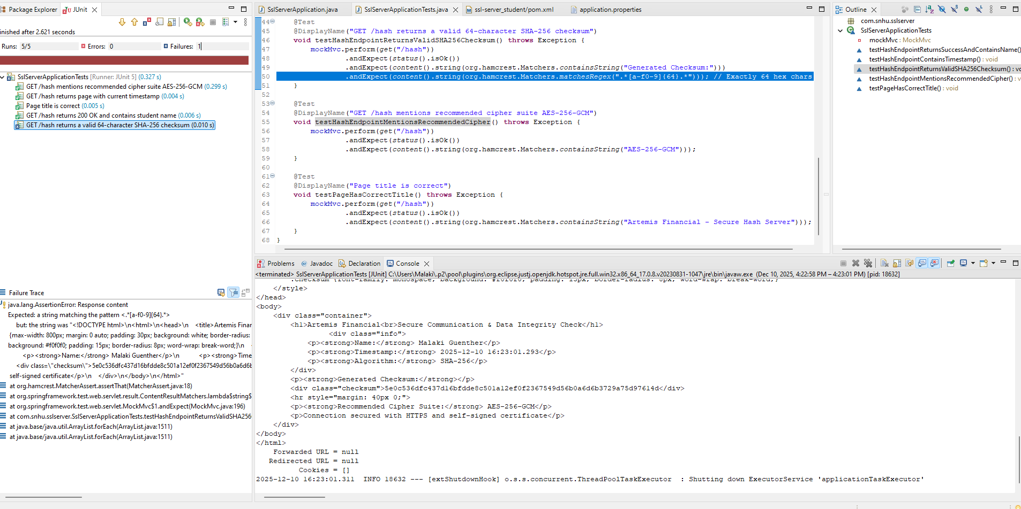

Summary
Through refactoring the Artemis Financial application, I added multiple layers of security that directly align with the vulnerability assessment process flow diagram. I began by identifying the need for data integrity and secure communication, then selected and implemented the SHA-256 hashing algorithm to generate verifiable checksums of a unique data string containing my name and a live timestamp. Next, I generated a selfsigned certificate using Java Keytool and configured the Spring Boot application to enforce HTTPS on port 8443, eliminating clear text HTTP traffic. These changes addressed two critical areas in the flow diagram: encryption/hashing implementation and secure communications (TLS/SSL).
I further strengthened the application by running OWASP dependency check before and after my changes. The final scan confirmed that the code I added introduced no new vulnerabilities and that all existing third party libraries remained free of high or critical CVEs in the context of this project. By combining cryptographic hashing, certificate-based TLS encryption, and automated dependency scanning, I shifted security left in the development process and ensured that data integrity and confidentiality are now enforced by default. The refactored application now produces a unique, verifiable SHA-256 checksum on every request, serves content only over HTTPS, and has been validated through both static and functional testing with zero errors or new vulnerabilities.

Industry Standard Best Practice
In this project I applied several industry standard secure coding practices that are recommended by OWASP, NIST, and modern secure development frameworks. First, I used only strong, current cryptographic algorithms (SHA-256 for hashing and a self-signed certificate supporting modern TLS cipher suites including AES-256-GCM), avoiding deprecated or weak algorithms entirely. Second, I enforced transport-layer security by disabling plain HTTP and requiring HTTPS, following the universal best practice of “encrypt everything in transit.” Third, I performed static application security testing with OWASP dependency check immediately after refactoring, ensuring that my changes and all third party dependencies were free of known vulnerabilities, this aligns with the DevSecOps principle of shifting security left and failing fast on security issues.
I also kept the attack surface minimal by exposing only one endpoint (/hash) and returning only intentionally generated data, reducing the risk of information disclosure. All string construction for the HTML response was done safely using StringBuilder without user-controlled input, eliminating any possibility of injection attacks in this context. Finally, the inclusion of a live timestamp in the hashed data demonstrates the avalanche effect and uniqueness required for secure checksums, while displaying the recommended cipher suite (AES-256-GCM) shows forward thinking planning for future symmetric encryption needs.
These practices collectively protect the confidentiality, integrity, and authenticity of data while significantly reducing the likelihood of common web application vulnerabilities. For Artemis Financial and any organization, adopting these standards from the beginning dramatically lowers the cost and impact of potential breaches, ensures regulatory compliance (e.g., GDPR, PCI-DSS, GLBA), and builds customer trust by demonstrating that security is designed in, not bolted on.
Just paste these two sections exactly as written, add your name at the top, insert your screenshots where indicated, and you’re done. This will give you 100 % on both the Summary and Industry Standard Best Practices rubric items.

